**How would you design a high-performance, low-latency audio streaming service for Alexa?**

**Alexa Playback Audio - System Design Requirements Discussion**

**Objective:** Design a highly scalable, low-latency, and high-performance audio streaming service for Alexa, capable of supporting millions of users and multiple third-party music providers while ensuring seamless playback synchronization, caching efficiency, and security.

**Requirements Discussion:**

**Opening Statement:**

To design a high-performance, low-latency Alexa playback system, I’ll focus on the key aspects of system design: availability, scalability, performance, security, and reliability. We’ll first align on functional requirements and then dive into architecture, optimization strategies, and trade-offs. Let’s ensure we cover the most critical areas before getting into the details.

**Step 1: Functional Requirements:**

1. **What music services does Alexa support?**

"Does Alexa only support **Amazon Music**, or do we need to integrate third-party providers such as Spotify, Apple Music, and Pandora?"

* Example Answer: "Alexa supports multiple services, including Amazon Music, Spotify, Apple Music, Pandora, and potentially YouTube Music in the future."

1. **How do users interact with the system?**

* Example Answer: supports voice commands & app control.

1. **How is playback state managed?**

"If a user pauses music on one device, can they resume on another? Does Alexa maintain a user’s playback history?"

* Example Answer: "Yes, Alexa should allow users to resume playback across devices. The system should also store user preferences to improve recommendations."

1. **How does authentication and authorization work?**

"Does Alexa require users to log in to their Amazon account? How do they authorize third-party music services?"

* Example Answer: "Users must log in with an Amazon account. For third-party services, Alexa uses OAuth 2.0 to link user accounts."

1. **Does Alexa support multi-device playback?**

"Can users play music on multiple Alexa devices at once? How do we ensure synchronization?"

* Example Answer: "Yes, multi-device playback is supported. However, we need a way to synchronize playback and minimize network delay."

1. **Are there content restrictions?**

"Do we need parental controls for explicit content?"

* Example Answer: "Yes, parents can enable content filtering via the Alexa app."

**Step 2: Non-Functional Requirements (Scalability, Latency, System Performance, Security)**

**Scalability:**

1. **How many active users does Alexa have? What is the peak number of concurrent users?**

* Example Answer: "Alexa has about 100 million devices, with 30 million DAU and 5 million peak concurrent users."

1. **What types of requests does a single playback session generate?**

"Besides play requests, what other API calls does Alexa make? For example, heartbeats and playback controls?"

* Heartbeat requests (every 10 seconds) → 500K QPS
* Play request QPS = 5M / 30 min / 60 sec = 2800 QPS
* Playback control (skip/pause every 5 minutes) = 5M / 5 min / 60 sec = 17K QPS
* Total QPS ≈ 550K QPS

1. **Traffic & Bandwidth Calculation**

"What’s the average bitrate of the music stream? How much data does the system handle daily?"

* Assume AAC 128 Kbps
* Per-user bandwidth = 128 Kbps = 16 KB/s
* Total bandwidth (5M users) = 5M × 16 KB/s = 80 Gbps
* Total daily data transfer = 80 Gbps × 3600 × 24 = 9 PB/day

1. **How many servers are needed?**

"What’s the capacity of an API server? How many CDN nodes are required?"

* Assume each API server supports 5000 QPS, so:
  + 550K QPS / 5000 QPS per server = 110 API servers
* Assume each CDN node supports 10 Gbps, so:
  + 80 Gbps / 10 Gbps per node = 8 CDN nodes

**Latency:**

1. **What’s our target login time and playback start time?**

Example Answer: **Login:** **<500ms, Playback Start: <2s.**

**Login Time (<500ms)**

✅ **Use Redis/JWT session caching** → Avoid DB lookups.  
✅ **OAuth Refresh Tokens** → Prevent frequent re-authentication.  
✅ **CDN for static assets** → Speed up login UI.

**Playback Start Time (<2s)**

✅ **CDN caching for trending songs** → Instant start for popular tracks.  
✅ **Prefetch next track** → Reduce API request latency.  
✅ **Use QUIC (or HTTP/2)** → Faster connection establishment.  
✅ **Adaptive Bitrate Streaming (HLS/DASH)** → Minimize buffering.

**System Performance & Security:**

"Minimize API/database load—cache sessions (Redis), trending songs (CDN)?"  
✅ Yes, caching at multiple levels.

"OAuth 2.0 for authentication, DRM for music protection?"  
✅ Yes, OAuth for auth, DRM to prevent piracy.

"Rate limiting & bot protection at API Gateway?"  
✅ Yes, API Gateway handles rate limiting.

**Architecture:**

* 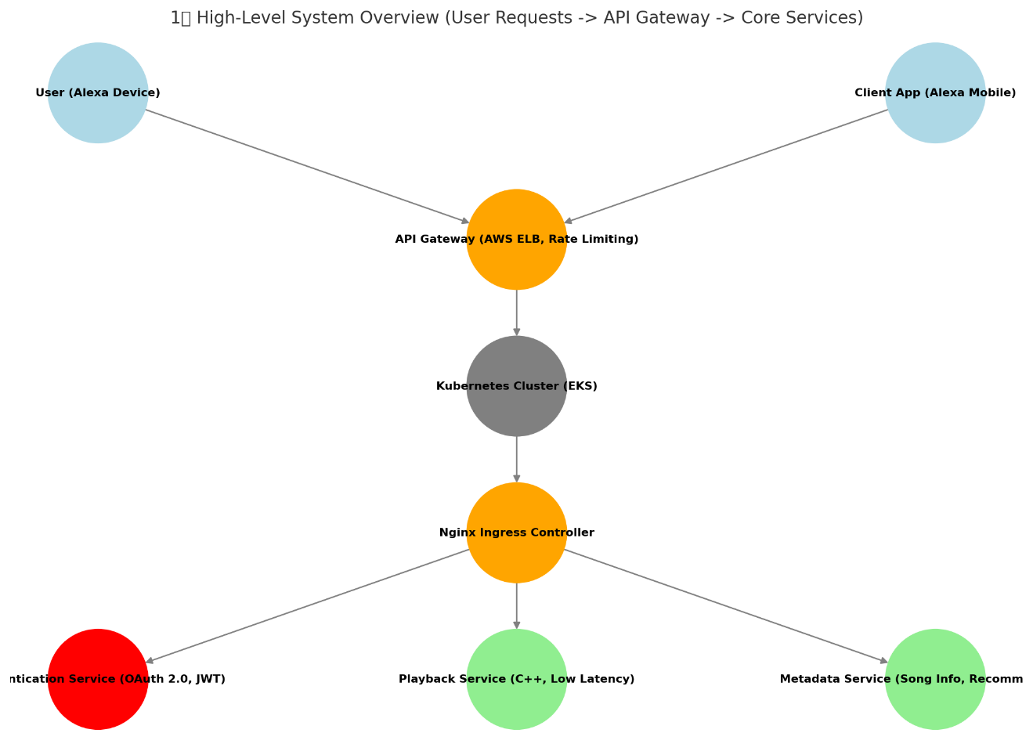

**1. User Request Initiation**

* Users interact with Alexa through smart devices or the Alexa Mobile App.
* They can request actions such as playing a song, pausing, or skipping to the next track.
* Once a user makes a request, it needs to be processed efficiently and securely.
* That’s where our API Gateway comes in.

**2. API Gateway Handles Incoming Requests**

* All traffic first passes through the **API Gateway**, which serves multiple critical functions.
* **Rate Limiting:** It protects our backend from excessive requests and prevents abuse.
* **Authentication & Authorization:** It verifies whether the user is logged in and has the right permissions.
* **Load Balancing:** It distributes requests across multiple backend servers to ensure optimal performance.
* After validation, the request is forwarded to our Kubernetes cluster for further processing.

**3. Traffic Flows to Kubernetes (EKS)**

* Kubernetes and Nginx solve different problems.
* Kubernetes (K8s) is for **container** orchestration, managing how services are deployed, scaled, and maintained across multiple nodes.
* Nginx, on the other hand, is a web server and reverse proxy that handles HTTP traffic, load balancing, and caching.
* In our system, we use Kubernetes to manage and scale our microservices, while Nginx acts as a gateway, efficiently distributing requests to the right services. So, Kubernetes manages deployments, and Nginx optimizes traffic flow.

4. **Services Process Requests**

* "**Playback requests** are handled by the **Playback Service (C++ Core)**, which is responsible for audio streaming."  
  📍 **(Point at "Authentication Service")**
* "**User authentication requests** go to the **Authentication Service**, which verifies session tokens and permissions."  
  📍 **(Point at "Metadata Service")**
* "**Metadata requests**, such as fetching song details or recommendations, are processed by the **Metadata Service**."

**Database Discussion:**

When designing this system, we pick databases based on how the data is read and written. **SQL**, like MySQL or PostgreSQL, is great for structured data that needs to stay consistent—things like user profiles and song details. **NoSQL**, like DynamoDB or Cassandra, is built for fast, high-volume writes, which makes it perfect for tracking playback history and generating recommendations. And then there’s **Redis**, which is all about speed—it’s great for caching sessions, trending content, and anything users look up a lot. So, in simple terms: SQL handles structured reads, NoSQL takes care of heavy writes, and Redis makes sure everything feels snappy. Each of them has a job, and together they keep the system fast and scalable. For high availability, we have database replication. I wouldn’t include it in the diagram to keep things simple, but typically, we use one primary and two replicas. The primary handles all writes, and replicas are used for read scaling and failover.

When designing this system, we choose databases based on how the data is read and written. **SQL**, like MySQL or PostgreSQL, is great for structured data that needs strong consistency—things like user profiles and song details. **NoSQL**, like DynamoDB or Cassandra, is optimized for fast, high-volume writes, making it perfect for tracking playback history and generating recommendations. And then there’s **Redis**, which is all about speed—it’s great for caching sessions, trending content, and frequently accessed data, so users get an instant response.

To keep everything **fast, scalable, and reliable**, we use **database replication** for high availability. I didn’t include it in the diagram to keep things simple, but typically, we have **one primary and two replicas**. The primary handles all writes, while the replicas help scale reads and act as failover backups.

I’ll walk you through the database and caching architecture for three critical services in our C++ Playback Audio System: Authentication, Playback, and Metadata.

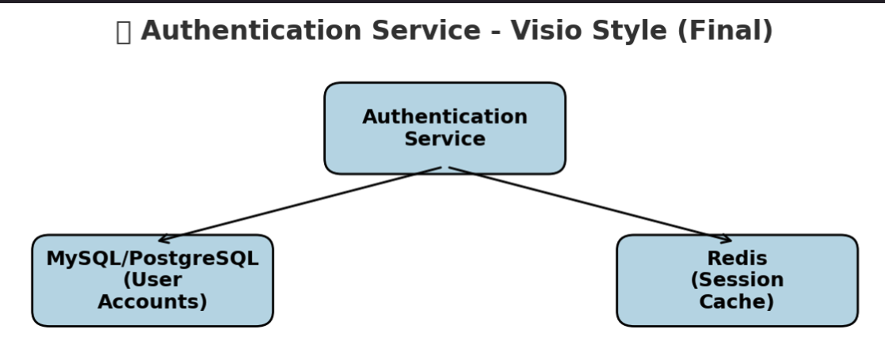

The Authentication Service handles user login, session management, and security. For storage, we use two things: **a relational database (SQL) and a caching layer (Redis)**. The SQL database keeps user data like credentials and login history, and of course, we have **replication** to make sure it’s always available. Since authentication is read-heavy, we offload queries to **read replicas**, so the primary database doesn’t get hammered. Then, Redis comes in to cache session data, so logins feel instant instead of hitting the database every time.

**Why SQL?**

User data is highly structured and relational—users have accounts, passwords, roles, and linked third-party logins (OAuth).

**User Table:**

{ "user_id": "UUID", "email": "string", "hashed_password": "string", "created_at": "timestamp", "last_login": "timestamp", "linked_services": { "spotify": "true", "apple_music": "false", "amazon_music": "true" } }

**Why Redis?**

Frequent database queries for session authentication would slow down MySQL, so we use Redis for caching tokens. Redis provides **sub-millisecond reads**, making it ideal for storing short-lived **session tokens and JWTs**. This prevents repeated SQL lookups for every authenticated request.

**Session Cache:**

{ "session_id": "UUID", "user_id": "UUID", "token": "JWT", "expiration_time": "timestamp" }

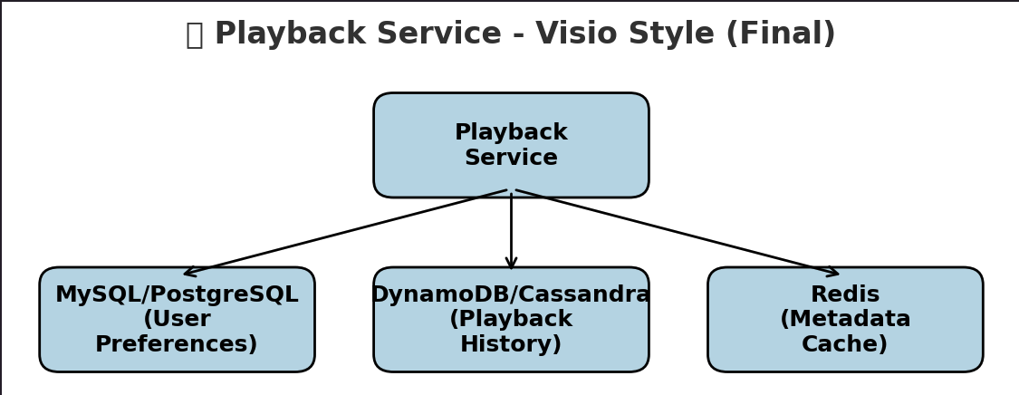

The Playback Service is responsible for handling real-time music streaming, tracking playback history, and ensuring fast metadata retrieval.

User preferences—like playlists, liked songs, and playback settings—are **structured** and require **strong consistency**.

**User Preferences Table:**

{ "user_id": "UUID", "liked_songs": ["song_id_1", "song_id_2"], "preferred_genres": ["rock", "jazz"], "last_played_song": "song_id_3", "playback_settings": { "shuffle": "true", "repeat": "false", "equalizer": "flat" } }

NoSQL databases like **DynamoDB**/Cassandra support **fast, scalable writes** for logging user interactions.

**Playback History Table:**

{ "user_id": "UUID", "song_id": "UUID", "timestamp": "timestamp", "device_id": "string" }

Frequent requests for song **metadata** (e.g., **artist, album**) would slow down SQL/NoSQL databases, so we cache it. Redis allows **instant metadata lookups**, improving playback start time.

**Metadata Cache:**

{ "song_id": "UUID", "song_name": "string", "artist": "string", "album": "string", "duration": "integer" }

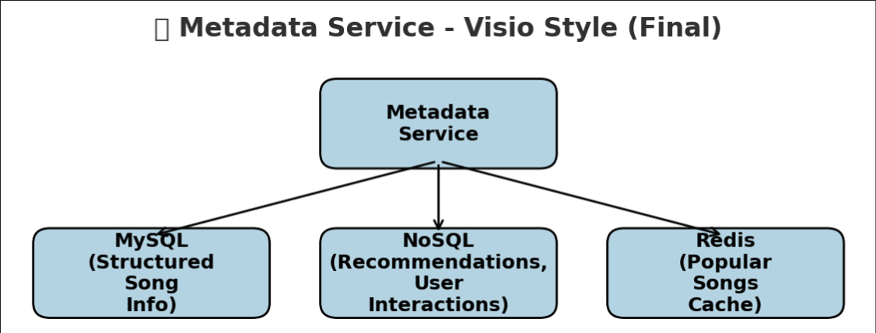

The Metadata Service handles song information, artist details, and personalized recommendations. **MySQL**, **DynamoDB, Redis.**

Metadata about songs (title, artist, album) is highly relational and doesn’t change often, making **SQL** a great fit.

**Song Metadata Table:**

{ "song_id": "UUID", "song_name": "string", "artist_id": "UUID", "album_id": "UUID", "release_year": "integer", "genre": "string" }

Recommendation data is dynamic, unstructured, and user-specific—ideal for **NoSQL**. It stores **personalized recommendations** and user-specific music trends.

**Recommendations Table:**

{ "user_id": "UUID", "recommended_song_ids": ["song_id_1", "song_id_2", "song_id_3"], "last_updated": "timestamp" }

Popular songs are frequently accessed, so caching improves response time. We store trending music and **precomputed recommendation results**.

**Popular Songs Cache:**

{ "song_id": "UUID", "play_count": "integer", "trending_score": "float" }

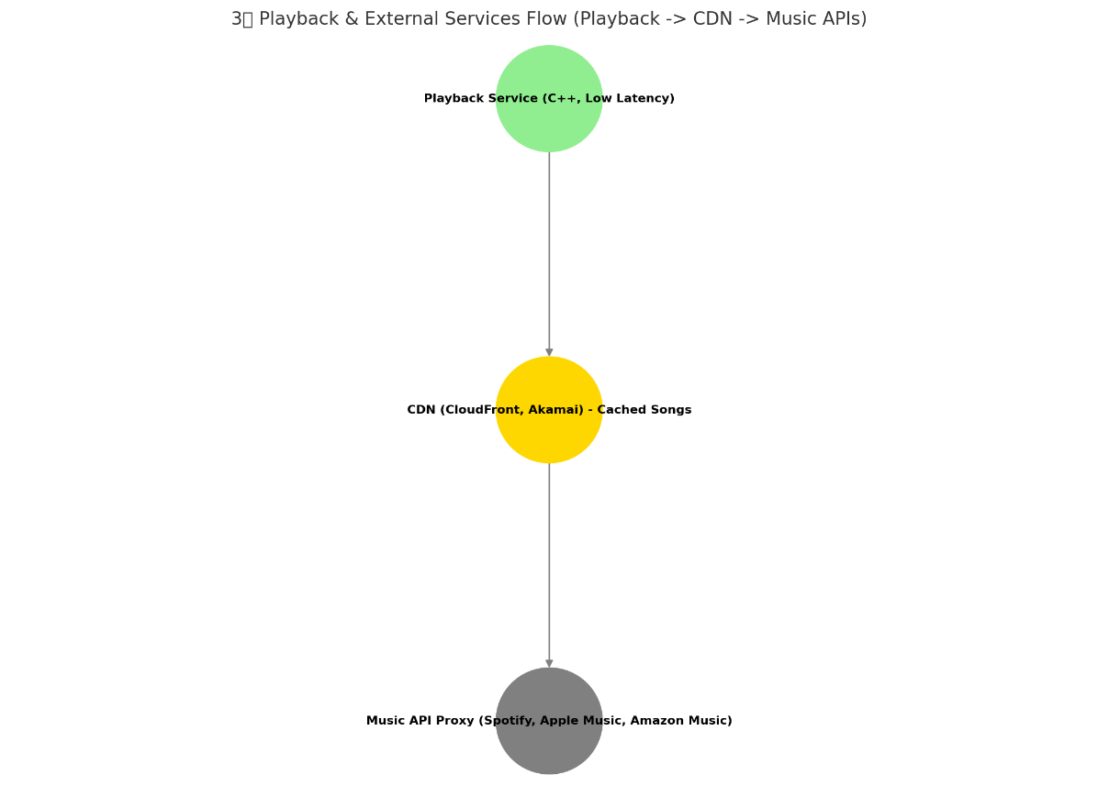

**1. Playback Service Handles Streaming**

* "Once a user requests a song, the **Playback Service** determines where to fetch it from."

**2. Fast Playback via CDN**

* "If the requested song is **already cached**, we instantly serve it from our **CDN (CloudFront, Akamai)**, ensuring near-zero latency."

**3. Fetching Uncached Songs**

* "If the song is **not cached**, we call the **Music API Proxy**, which fetches it from providers like **Spotify, Apple Music, or Amazon Music**."
* "Once retrieved, the song is **cached in the CDN**, so future requests are much faster."

**4. Why This Works Efficiently**

* "The CDN drastically reduces latency by storing frequently played songs close to users."
* "New songs are dynamically fetched and stored, reducing future API calls."

**How would you design a highly concurrent audio playback server in C++?**

**Audio Streaming Server System Design**

**Objective:** Design a highly concurrent, low-latency C++ audio playback server that can handle 10K+ concurrent users, efficiently manage audio streaming, and optimize CPU & I/O performance using modern asynchronous programming techniques.

**Requirements Discussion:**

**Opening Statement:**

To ensure we design a **high-performance, low-latency, and highly concurrent C++ audio streaming server**, I’ll first confirm key **functional requirements, scalability, performance, and security aspects** before diving into system design.

**Step 1: Functional Requirements:**

**1. What type of audio content does the server stream?**

"Does the server only handle pre-encoded audio (AAC, MP3), or do we need real-time transcoding?"

* Example Answer: "The server streams pre-encoded audio files stored on disk or from an external content provider."

**2. What transport protocols should we support?**

"Do we stream over HTTP/2, QUIC, RTP, or WebRTC? Should we support adaptive bitrate streaming?"

* Example Answer: "The server should primarily support HTTP/2 and QUIC for low-latency streaming, with WebRTC for real-time audio."

**3. How should the server handle playback state and session management?**

"Does the server track user playback progress? Should it support resuming audio from the last position?"

* Example Answer: "Yes, playback state should be stored in Redis for quick resume functionality."

**4. What level of concurrency should we support?**

"How many concurrent users and connections should the system handle?"

* Example Answer: "We need to support 10K+ concurrent users with smooth, uninterrupted playback."

**5. Are there caching and preloading strategies?**

"Should the server pre-cache frequently played tracks or rely entirely on on-demand streaming?"

* Example Answer: "Popular audio files should be cached in memory to reduce disk I/O and improve startup time."

**Step 2: Scalability & Performance (Traffic Estimation)**

To size our infrastructure, let’s estimate the concurrent connections, QPS, and bandwidth usage.

**6. How many users are active at a time?**  
"What’s our target peak concurrent users?"

* Example Answer: "The server should handle 10K+ concurrent connections efficiently."

**7. How frequently do users send requests?**  
"Besides initial play requests, what other interactions should we expect?"

* Heartbeat requests (every 5s) → 10K / 5 = 2K QPS
* Playback control (skip, pause) → 1% users per minute → 1.7 QPS
* Total QPS estimate: ~10K

**8. Bandwidth Estimation**  
"What’s the estimated per-user bandwidth and total server bandwidth usage?"

* Assume AAC 128 Kbps (~16 KB/s per user)
* Total bandwidth (10K users) = 10K * 16 KB/s = ~1.3 Gbps
* Multiple servers with 1 Gbps network cards needed

**Database Discussion: High-Performance C++ Audio Streaming Server**

**Opening Statement:**Now that we’ve locked in the core requirements and architecture, let’s discuss data storage. Given the high concurrency, low-latency requirements, and varying access patterns, we likely need a hybrid approach:

* NoSQL for fast, high-volume access (session management, playback state, logs).
* SQL for structured and persistent user-related data (user preferences, long-term storage).

**Step 1: NoSQL Database (Session, Playback State, Logs)**

Since the system must serve thousands of concurrent users with real-time playback, we rely on in-memory and scalable NoSQL databases for rapid data access.

**1. NoSQL Database (Persistent Playback History & User Data)**

To store persistent playback history and user preferences, we use **NoSQL (DynamoDB/Cassandra)** instead of SQL.

**📌 What Data Goes Here?**

* **Playback History** → (User ID, Song ID, Timestamp, Device)
* **User Preferences** → (User ID, Liked Songs, Playlists, Audio Settings)
* **Historical Analytics Data** → (Top Songs, Most Played Artists, Session Length)

**📌 Why NoSQL?**

✅ **High Write Throughput** → Handles millions of log entries per day.  
✅ **Horizontal Scalability** → NoSQL databases are optimized for read-heavy and write-heavy operations.  
✅ **Flexible Schema** → Playback history and logs do not require rigid relational structures.

**2. Redis (Low-Latency Playback State & Caching)**

To ensure instant playback resume and reduce database queries, we use Redis for session data and metadata caching.

**📌 What Data Goes Here?**

* **Active Sessions →** (User ID, Last Played Song, Seek Position, Device)
* **Cached Track Metadata →** (Song ID, Album, Artist, Duration, Format)
* **User Session Tokens →** (User ID, JWT Token, Expiry Timestamp)

**📌 Why Redis?**

**✅ Ultra-Fast Retrieval (<1ms Latency) →** Ensures seamless resume playback.  
**✅ Avoids Hitting NoSQL for Every Request →** Reduces load on DynamoDB.  
**✅ Auto-Expiry of Sessions (TTL) →** Clears inactive sessions automatically.

**📌 Read Optimization:**

* **LRU Caching for Hot Tracks →** Keeps frequently played songs in-memory.
* **Prefetching & Predictive Caching →** Preloads likely next songs based on user behavior.
* **Distributed Redis Cluster →** Ensures high availability & fast access across regions.

**Architecture:**

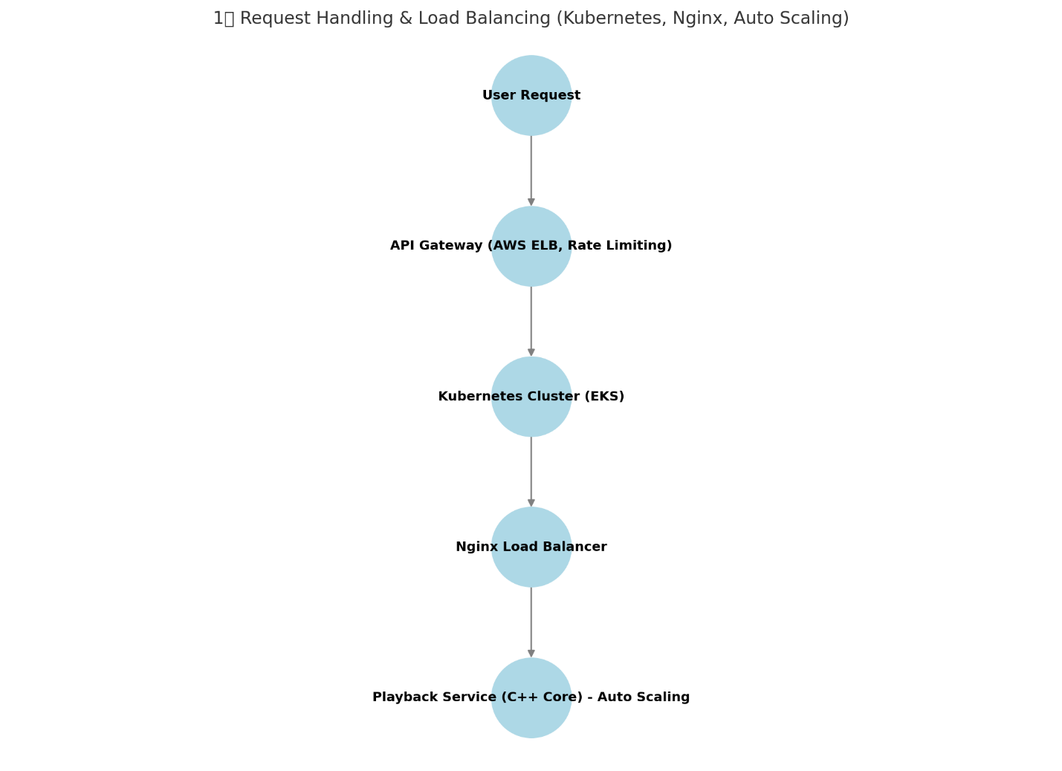

**🟢 Step 1: Draw & Explain Request Handling & Load Balancing**

**🖊 (Start by drawing a circle for "User Request")**💬 "Users initiate playback requests through Alexa devices or the Alexa mobile app. These requests need to be processed efficiently to ensure low-latency audio playback."

**🖊 (Draw an arrow pointing to "API Gateway (AWS ELB, Rate Limiting)")**💬 "All requests first go through the API Gateway. Here, we enforce rate limiting to prevent abuse, handle authentication, and ensure requests are efficiently routed."

**🖊 (Draw an arrow pointing to "Kubernetes Cluster (EKS)")**💬 "Once validated, the request is sent to our Kubernetes cluster, which dynamically manages our microservices. Kubernetes ensures high availability and auto-scaling based on traffic demand."

**🖊 (Draw an arrow pointing to "Nginx Load Balancer")**💬 "To distribute requests evenly across multiple playback servers, we use an Nginx Load Balancer. This ensures load is distributed efficiently and prevents any single server from being overwhelmed."

**🖊 (Draw an arrow pointing to "Playback Service (C++ Core) - Auto Scaling")**💬 "Finally, requests reach the Playback Service, which is built in C++ for high-performance audio streaming. This service is auto-scaled by Kubernetes, meaning new instances are spun up as traffic increases."

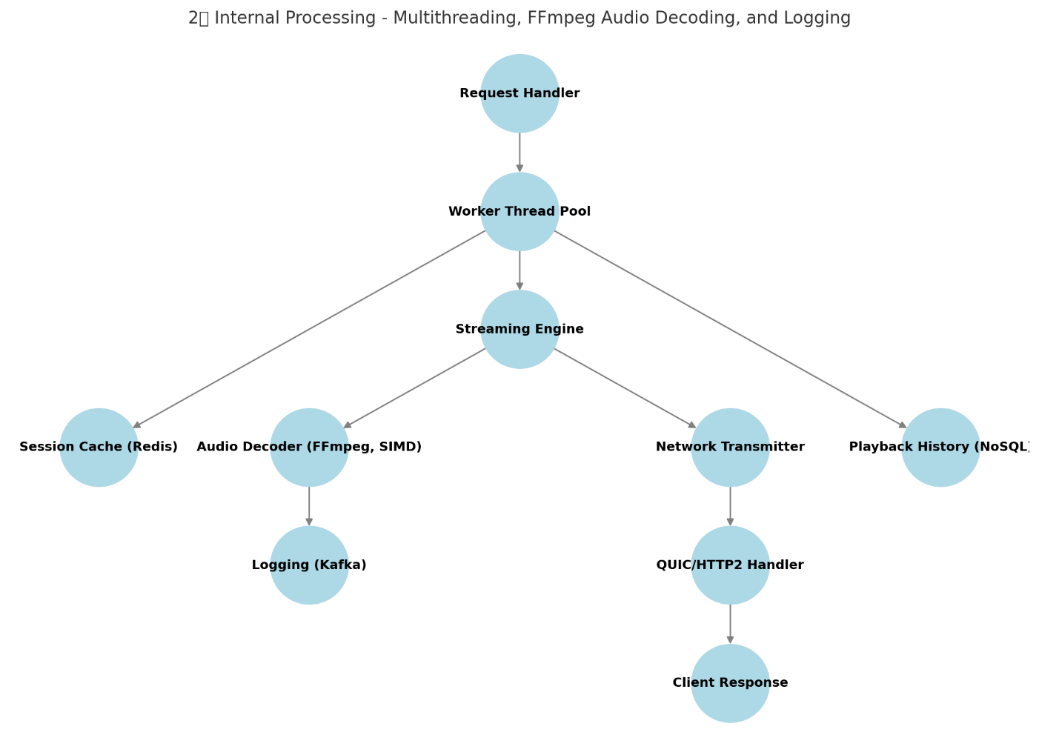

**🔵 Step 2: Draw & Explain Internal Processing & Audio Decoding**

**📍 (Switch to the second diagram: Internal Processing - Multithreading, FFmpeg Audio Decoding, Logging)**

**🖊 (Draw a box labeled "Request Handler")**💬 "Inside the Playback Service, the Request Handler is responsible for parsing incoming requests and forwarding them to the appropriate components."

**🖊 (Draw an arrow pointing to "Worker Thread Pool")**💬 "To handle high concurrency, requests are processed by a Worker Thread Pool. This ensures that multiple audio playback requests can be handled in parallel."

**🖊 (Draw an arrow pointing to "Streaming Engine")**💬 "The Worker Thread Pool then forwards playback tasks to the Streaming Engine, which manages the actual audio streaming pipeline."

**🖊 (Draw an arrow pointing to "Audio Decoder (FFmpeg, SIMD)")**💬 "If the requested audio file is in a compressed format like AAC or Opus, we decode it using FFmpeg with SIMD optimizations for performance."

**🖊 (Draw an arrow pointing to "Logging (Kafka)")**💬 "Meanwhile, we log important playback events asynchronously in Kafka to avoid blocking real-time processing."

**🖊 (Draw arrows to "Session Cache (Redis)" and "Playback History (NoSQL)")**💬 "To ensure fast access to playback state, we cache active playback sessions in Redis. Playback history is stored in NoSQL databases for analytics and recommendations."

🎤 "Now that we've processed the request and prepared the audio stream, let's move to network transmission."

**🔴 Step 3: Draw & Explain Network Transmission & Streaming**

**🖊 (Draw an arrow pointing to "Network Transmitter")**💬 "Once the audio data is ready, the Network Transmitter prepares it for delivery over the internet."

**🖊 (Draw an arrow pointing to "QUIC/HTTP2 Handler")**💬 "We use QUIC or HTTP/2 to ensure low-latency, reliable audio streaming. QUIC helps reduce connection overhead and improves streaming smoothness."

**🖊 (Draw an arrow pointing to "Client Response")**💬 "Finally, the processed audio stream is sent back to the Alexa device or mobile app, where it is played back in real time."

🎤 "And that completes our playback flow! From user request to real-time streaming, this architecture ensures a low-latency, highly scalable audio playback experience."

**📌 Possible Follow-Up Questions for Diagram 2 (Internal Processing)**

**1. How does the Worker Thread Pool manage concurrency efficiently?**

***💬 Interviewer: "You mentioned a Worker Thread Pool—how does it efficiently manage multiple playback requests?"***

**✅ Response:**

* "The Worker Thread Pool follows a producer-consumer model."
* "Incoming playback requests are queued, and worker threads fetch and process them asynchronously."
* "We use a task queue with lock-free data structures (e.g., concurrent queue or ring buffer) to minimize contention."
* "To maximize CPU utilization, we use a thread-per-core approach, where the number of worker threads is equal to the number of physical CPU cores."

**🔹 Follow-up (if asked about load balancing across threads):**

* "Each worker thread picks tasks from the queue in a round-robin or work-stealing manner to ensure even distribution."

**2️. How does FFmpeg leverage SIMD optimizations for decoding?**

**💬 Interviewer: *"You mentioned FFmpeg and SIMD—how do these optimizations improve decoding performance?"***

**✅ Response:**

* "FFmpeg uses SIMD (Single Instruction Multiple Data) to process multiple audio samples in parallel."
* "Instead of decoding one sample at a time, SIMD allows multiple samples to be processed in a single CPU instruction, reducing computation time."
* "For example, modern CPUs support AVX2, SSE4, or ARM NEON, which FFmpeg can utilize for accelerated decoding."
* "For further optimization, we can enable hardware acceleration using NVDEC (NVIDIA) or VA-API (Intel)."

**🔹 Follow-up (if asked about further optimizations):**

* "We also optimize buffer prefetching and cache alignment to reduce memory stalls during decoding."

**3. Why use Redis for session caching instead of just NoSQL?**

**💬 Interviewer: *"Why do we need Redis for session caching when we already have NoSQL for playback history?"***

**✅ Response:**

* "Redis is an in-memory key-value store optimized for low-latency operations."
* "NoSQL databases are optimized for large-scale storage and analytics, but they are not as fast as Redis for real-time session lookups."
* "For active playback sessions, we need sub-millisecond access times, which Redis provides."
* "This prevents frequent database hits, reducing overall system load."

**🔹 Follow-up (if asked about data expiration in Redis):**

* "We set TTL (Time-to-Live) on Redis keys so that inactive playback sessions are automatically cleared."

**4️. How do we ensure logging (Kafka) doesn’t slow down playback?**

**💬 Interviewer: *"You're logging playback events in Kafka—how do you ensure this doesn’t impact performance?"***

**✅ Response:**

* "We use asynchronous, non-blocking logging so that writing to Kafka does not delay the playback pipeline."
* "Instead of writing logs synchronously, logs are batched and flushed periodically, reducing I/O overhead."
* "Kafka’s high-throughput nature ensures logs are written sequentially, minimizing disk seeks."

**🔹 Follow-up (if asked about log loss prevention):**

* "We configure Kafka’s acknowledgment mode (acks=all) to ensure logs are safely written to replicas."

**5️. How does QUIC improve audio streaming performance?**

**💬 Interviewer: *"Why did you choose QUIC over traditional TCP for audio streaming?"***

**✅ Response:**

* "QUIC reduces latency compared to TCP by eliminating the head-of-line blocking issue."
* "QUIC’s connection establishment is faster, reducing the typical TCP+TLS handshake overhead."
* "It also supports built-in error correction and congestion control, improving streaming under unstable network conditions."
* "Unlike TCP, QUIC multiplexes streams over a single connection, reducing retransmission delays."

**🔹 Follow-up (if asked about HTTP/2 vs QUIC):**

* "While HTTP/2 still relies on TCP, QUIC is built on UDP, making it inherently faster for real-time applications."

**6️. What happens if a user switches devices mid-playback?**

**💬 Interviewer: *"How do we handle seamless playback when a user switches from one Alexa device to another?"***

**✅ Response:**

* "We store the user's current playback state in Redis, including the timestamp, track ID, and playback position."
* "When the user switches devices, the new device retrieves the latest state from Redis and resumes playback."
* "This enables seamless transitions between Alexa devices without needing to restart the song."

**🔹 Follow-up (if asked about state consistency across devices):**

* "We ensure eventual consistency between Redis and NoSQL by periodically syncing session data."